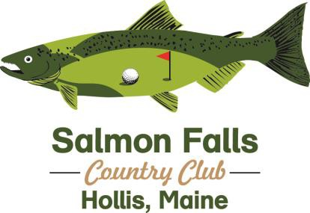

Web Site: www.salmonfallscountryclub.com

52 Golf Course Lane, Hollis Center, Me 04042
207-929-5233 Email: info@salmonfallscountryclub.com

Application for Membership
I/we hereby apply for membership to the Salmon Falls Country Club. If accepted for this membership (temporary or full) I/we agree to abide by the Rules of Salmon Falls Country Club

Personal Information (Please print and fill in completely)

Name: D.O.B

Spouse/Partner: D.O.B

Additional Family Member:: D.O.B

Additional Family Member: D.O.B.

Street City/Town Zip Residence Address (P.O. Box # not acceptable)

Phone number E-Mail Address

Employer Address City/Town

Membership Applied For: Membership Rate:
Status | Under 65 | Over 65/Veterans/1st Responders
Single (18 or over) | $1150 | $1035
Couple (includes children 6-12) | $1650 | N/A
Each additional child (13-18)  Senior Couple | $350  N/A | $1530
Junior (youth age 13-22) | $550 | N/A
Any HS Golf Team Member | $450 | N/A
Corporate Membership: Up to 4 People under company name | $3600
Weekday Only (unlimited play Monday-Friday excludes Corp 10% off eligible Membership Plans Annual Cart Plan (per person) $550 $500
Food/Beverage/Merchandise Plan (FB&M $500 of credit) $450 $450

Note 1. FB&M plans provide a 10% discount to all members and can be used at Salmon Falls Country Club and The River Tap & Grill. Minimum purchase each year of $500 “credit” per year after which cards can be loaded at any time and any increment and will achieve 10% discount when cash is loaded onto card.

Application Components
I/we understand that this application will not be accepted unless accompanied by each of the following:
Full Payment for the Membership Fees
A completed application for membership.

Fee Refunds:
I/we understand that this application with the enclosed fee (check or money order) will processed and I/we become members on the day of full payment.

I/we further understand that, I/we will have 30 days in which to:
- Request a refund less any applicable greens fees that would have been incurred during the 30 day period.
- Request a refund in writing to be delivered to SFCC within the 30-day period.
- No refunds will be granted if the 2022 membership was a “pay in 2021, play free offer”, or if request is submitted after the 30 day period

Signature: Date:

Type of Membership _________________________

Membership: $
FB&M Plan (not required): $
Cart Plan (not required): $
GHIN Fee $40.00 (not required): $

Sub-Total: $_____________

Total: $

Payment Method: CASH CREDIT CHECK

Received by: Date:

Entered By:

Refer a Friend:
Name: Phone: Email:

